Nav Bar – Blue Sky Balloons

**Home Experience Booking About**

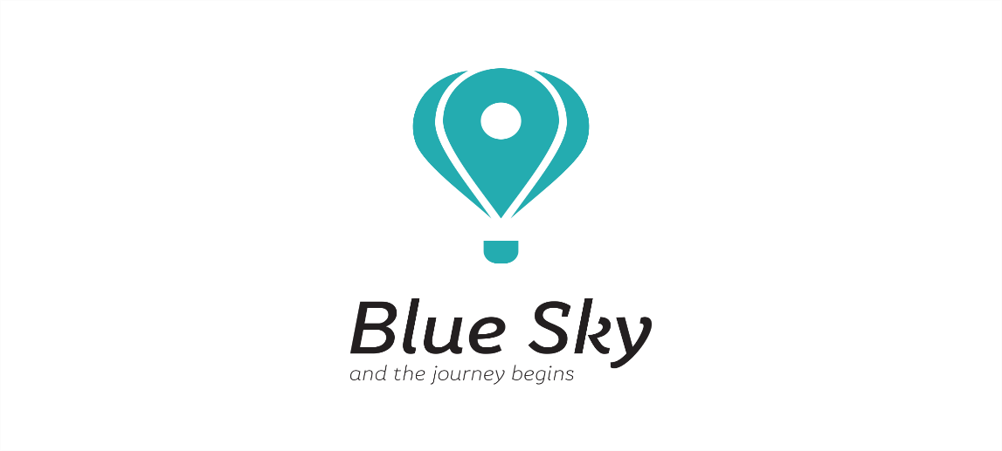

100 percent image. Logo either centered or far left.

Home

Experience

* Gallery
* Reviews

Booking

* Pricing
* Calendar of availability

About

* Bio on company
* Bio on pilot
* FAQ’s
* contact